PRACTICAL - 1
AIM: Identify the requirement and set objectives for a software project.
Scenario: Assume you are the project manager for a software development project. The project involves creating a new mobile application for a client. The client wants the application to enhance user engagement and include specific features.
Task:
- Identify the requirements and list the key objectives for the PS APP and Inventory Management system.
- Ensure that each objective follows the SMART criteria.
- Create Epic, Stories and Tasks using Jira software.
Solution :
Project Title : PS APP
Key Objective :
- Develop user authentication and profile management system.
- Implement an inventory management system for in-app purchases and DLC tracking.
- Create a content browsing feature for games and media.
- Enhance user engagement with achievements, rewards, and notifications.
- Ensure cross-device synchronization of user data and content.

SMART Criteria :
- Specific : Create an engaging, user-friendly mobile app with seamless onboarding, login, registration, password recovery, and a personalized home screen.
- Measurable : The app will achieve 90% user engagement by allowing users to register and log in easily, reducing drop-off during onboarding by 30%, and ensure password recovery is completed by at least 95% of users who request it.
- Achievable : Develop the app with the required features using an agile methodology, testing each feature in iterative sprints.
- Relevant : These features align with the client’s goal of increasing user engagement and retention through simplified access and personalized experience.
- Time-bound : The application should be completed within 8 weeks, with specific milestones at the end of each sprint (2 weeks per sprint).

Key Requirements :
Epic 1 : User Onboarding and Authentication
Story 1 : Landing/Onboarding Page
- Task 1 : Design the “Landing/Onboarding” page with an engaging introduction to the app.
- Task 2 : Add a “Get Started” button that leads to the login/registration page.
Story 2 : User Login
- Task 1 : Create a login page with email and password fields.
- Task 2 : Implement token-based authentication (JWT).
- Task 3 : Add an option for users to log in via social media accounts (Google/Facebook).
Story 3 : User Registration
- Task 1 : Design a Registration form with fields for username, email and password.
- Task 2 : Implement server-side validation for registration inputs.
- Task 3 : Store user registration data securely in the database.
Story 4 : Forgot Password
- Task 1 : Design a “Forgot Password” page with an email input for password reset.
- Task 2 : Implement email-based password recovery.

Epic 2 : Home Page and Content Display
Story 1 : Home Page Layout
- Task 1 : Design the homepage with a carousel for featured games.
- Task 2 : Create a section with game cards to display popular games.
- Task 3 : Implement a search bar for users to search specific games.
Story 2 : Game Interaction
- Task 1 : Implement tap functionality on game cards to view game details.
- Task 2 : Integrate a rating system to allow users to rate games.

Epic 3 : Shopping Cart and Favourite System
Story 1 : Shopping Cart
- Task 1 : Design the shopping cart page with options to view added items.
- Task 2 : Implement functionality to add, remove and edit items in the cart.
- Task 3 : Integrate the checkout process for in-app purchases.
Story 2 : Favourite System
- Task 1 : Add functionality to allow users to mark games as favourites.
- Task 2 : Display a list of favourite games on the “Favourite” page.

Epic 4 : Notification and User Profile
Story 1 : Notification System
- Task 1 : Implement a notification system to notify users of new content and updates.
- Task 2 : Design a notification page to show all user alerts.
Story 2 : User Profile
- Task 1 : Create a profile page to display personal details such as username, email and preferences.
- Task 2 : Add functionality to update personal details and preferences.
- Task 3 : Integrate a profile picture upload option.
- Task 4 : Also add a tab for the order history.
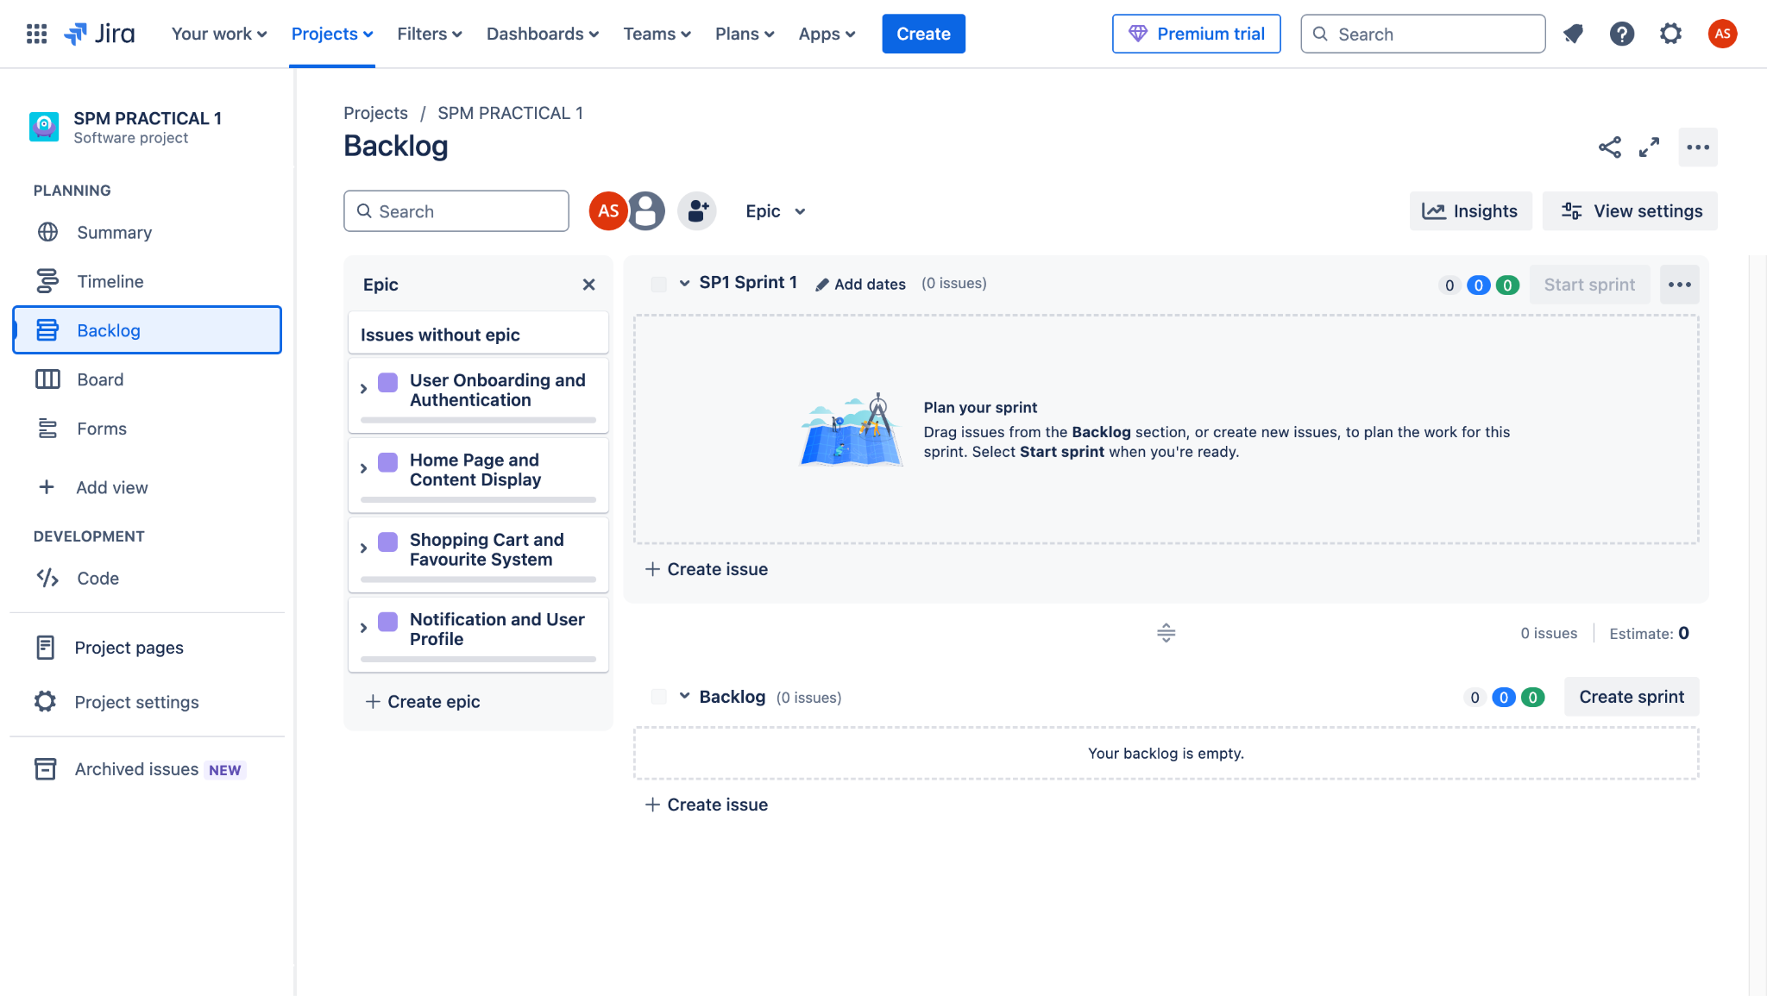

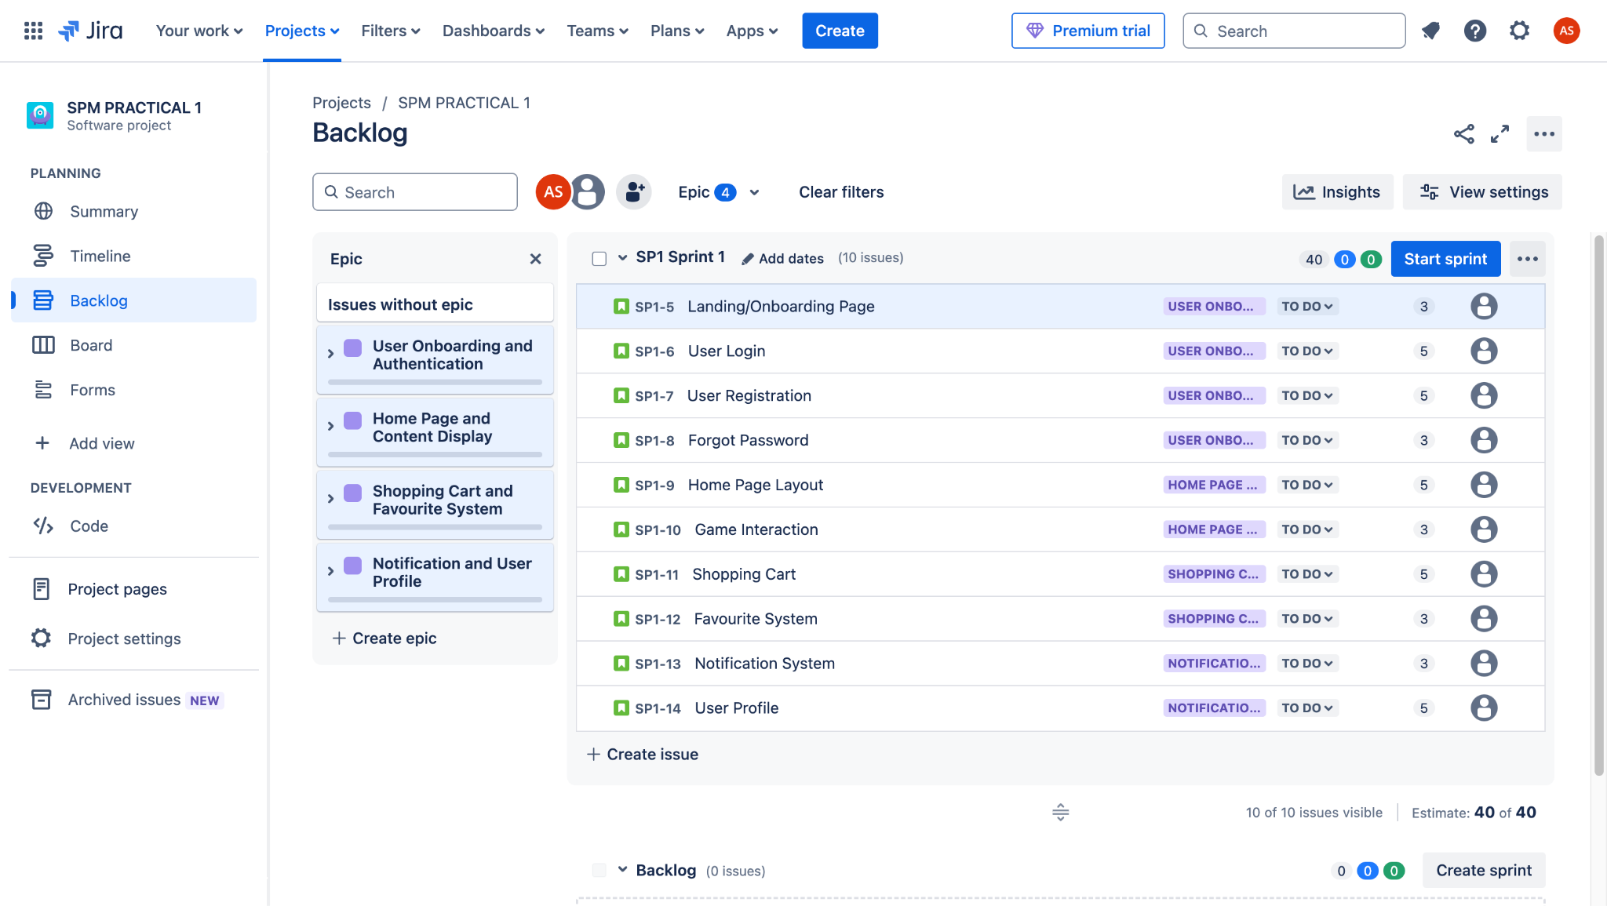
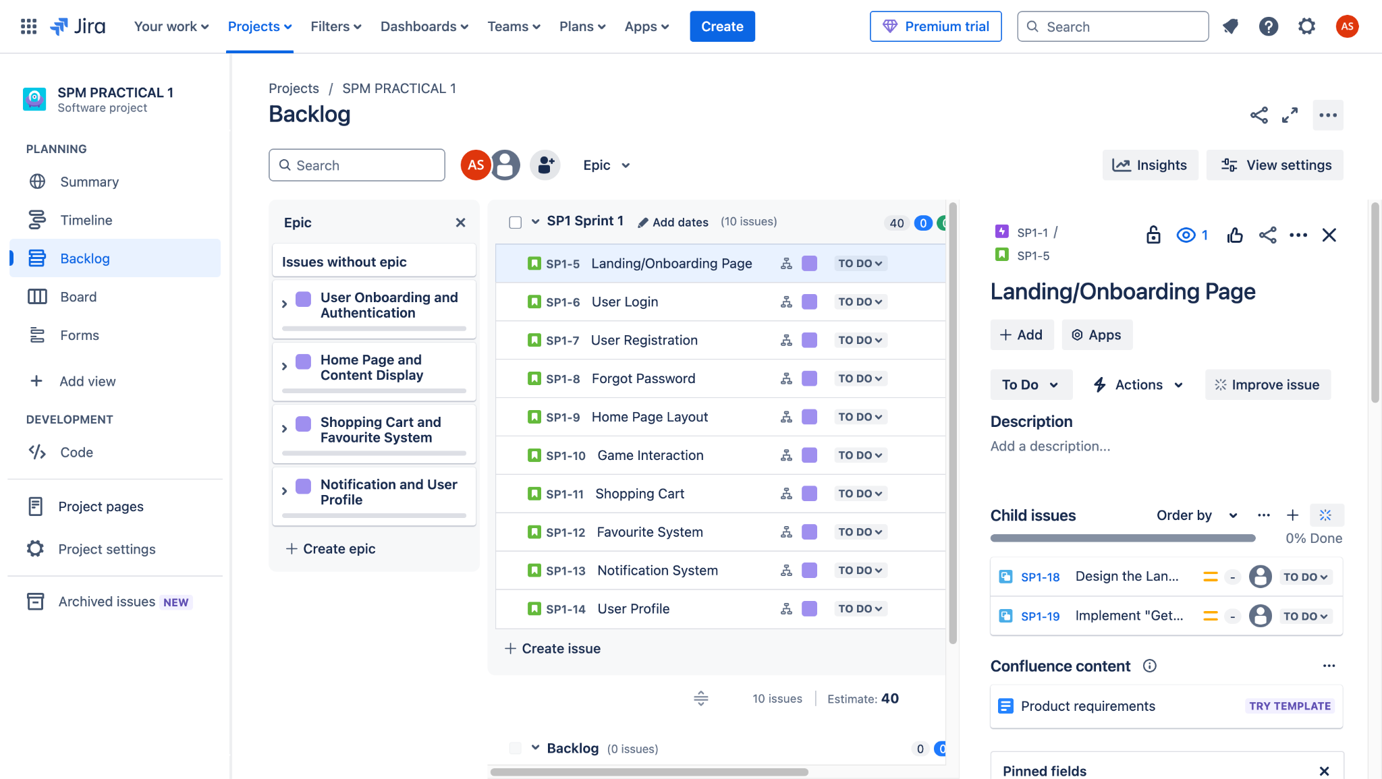

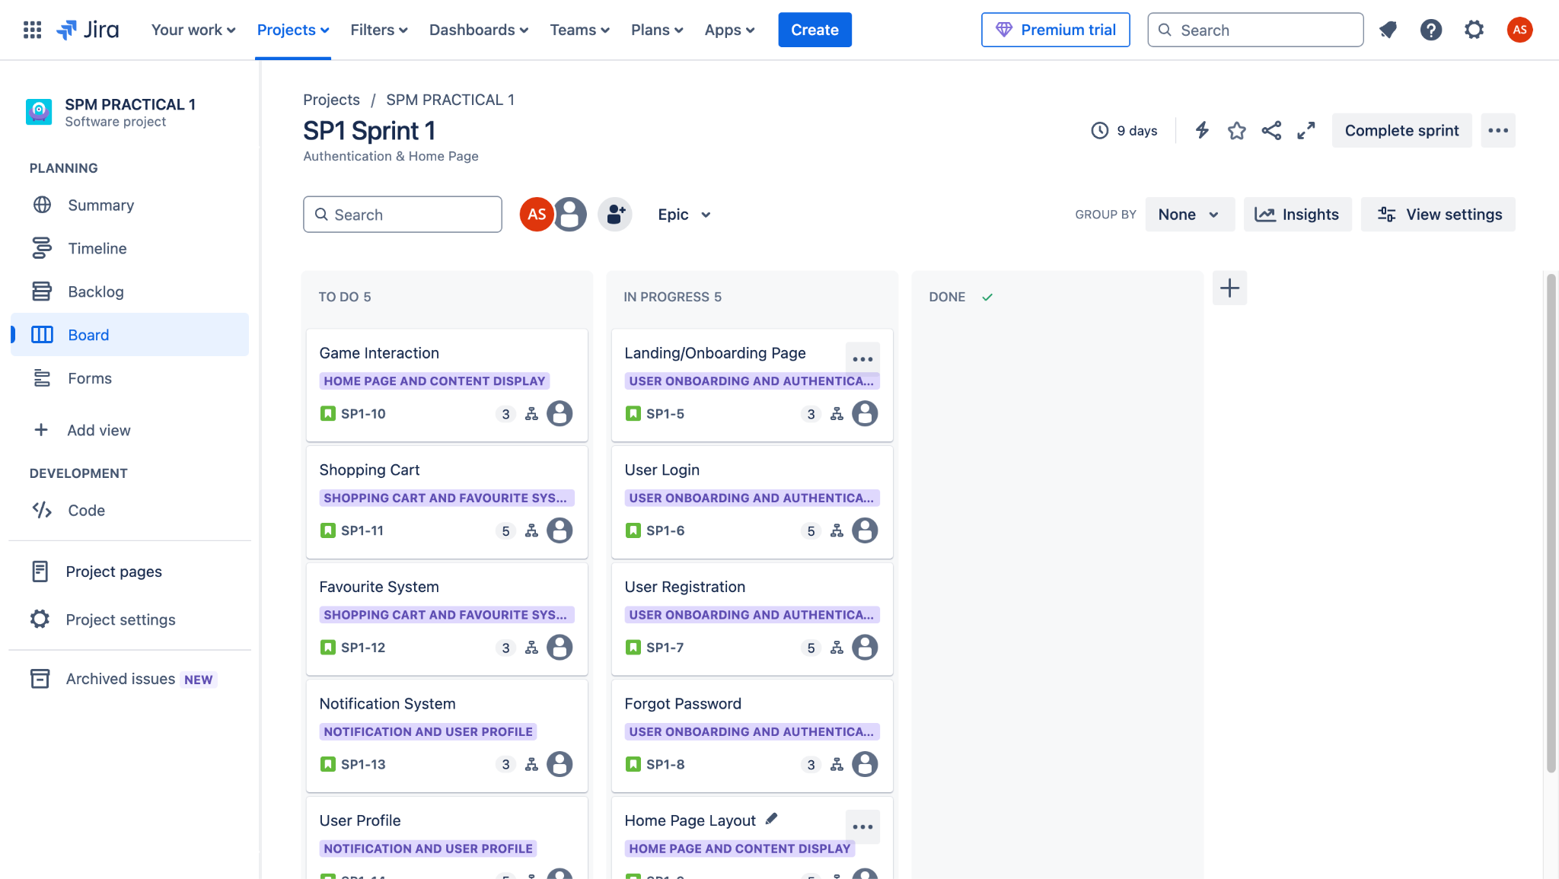

Project Title : Stock Inventory Management System
Key Objective :
- Develop a secure user authentication and role-based access system.
- Implement an efficient stock management system for tracking inventory levels and stock movements.
- Create a product catalog with categorization, search, and filtering options.
- Enable order management, including stock purchases, sales, and restocking.
- Implement a notification system for low stock alerts and order updates.

SMART Criteria :
- Specific: Build an inventory management system with features for product tracking, stock monitoring, order processing, and real-time notifications.
- Measurable: Ensure 95% accuracy in stock tracking, reduce manual inventory errors by 40%, and improve order processing efficiency by 50%.
- Achievable: Develop the system in iterative sprints using agile methodology with regular testing.
- Relevant: The system addresses the need for streamlined inventory tracking and order management, improving business efficiency.
- Time-bound: Complete the application within 8 weeks, with bi-weekly sprints focusing on key modules.

Key Requirements :
Epic 1 : User Authentication and Role Management
Story 1 : User Login & Role-Based Access
- Task 1: Implement a secure login system for admins, managers, and staff.
- Task 2: Restrict access based on user roles (e.g., only admins can add new products).
Story 2 :User Registration & Profile Management
- Task 1: Design a registration form for new users with role selection.
- Task 2: Implement profile management features for updating user details.
Story 3 : Password Recovery
- Task 1 : Implement a "Forgot Password" feature using email verification.\

Epic 2 : Stock Management System
Story 1 : Product Catalog
- Task 1: Develop a database schema for product details (name, SKU, price, quantity, supplier, etc.).
- Task 2: Create a product listing page with categorization and filtering options.
Story 2 : Stock Tracking & Updates
- Task 1: Implement real-time stock level tracking.
- Task 2: Add functionality to update stock when new items are received or sold.

Epic 3 : Order Management
Story 1 : Stock Purchase Orders
- Task 1: Create a module for adding new stock purchase entries.
- Task 2: Implement approval workflow for purchase orders.
Story 2 : Sales Order Processing
- Task 1: Develop an interface to create and manage sales orders.
- Task 2: Integrate automatic stock deduction when an order is confirmed.

Epic 4 : Notification & Reporting
Story 1 : Low Stock Alerts
- Task 1 : Implement an automatic alert system for low stock levels.
Story 2 : Order & Inventory Reports
- Task 1: Generate daily, weekly, and monthly reports on stock levels and order history.

